Time to start updating my apps. The first on the list is DECO (Design Editor for Custom Objects). Not only is this a must-have when using custom objects, but it gave me a chance to play with the new grid control in the Vault SDK. If you are unfamiliar with DECO, have a look at the page for the 2013 version.
I added one cool new feature for DECO 2014: a grid containing all the linked children. You can now view/add/delete links using UI created with DECO.
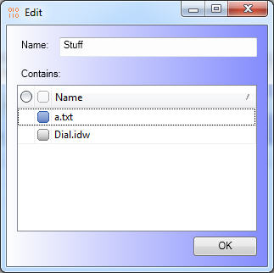
Have a look at this short video...

Requirements:
- Vault Professional 2014
- XAML editor such as Visual Studio Express or Expression Blend
Click here for the application
Click here for the source code

Issues / Limitations:
- Custom Objects only. No support for files, folders, items, and so on.
- The grid control only works with links to child entities. There is no way to show “where used” data in a DECO control.
- Vault Professional 2014 only, since that’s the only product with custom objects.
- Visual Studio 2010 has problems editing a XAML file with a WindowsFormsHost control. I don’t know about Visual Studio 2012.
- The XAML files and Settings.xml need to be distributed to all clients in order for them to see the custom UI. This issue will be addressed in the next release of Project Thunderdome.
As with all the samples on this site, the legal disclaimer applies.

